

Practices for Secure Software Report

Table of Contents
Document Revision History 3
Client 3
Instructions 3
Developer 4
1. Algorithm Cipher 4
2. Certificate Generation 4
3. Deploy Cipher 4
4. Secure Communications 4
5. Secondary Testing 4
6. Functional Testing 4
7. Summary 4
8. Industry Standard Best Practices 4

Document Revision History

Version | Date | Author | Comments
1.0 | 28 June 2026 | Victor Lane

Client



Instructions

Submit this completed practices for secure software report. Replace the bracketed text with the relevant information. You must document your process for writing secure communications and refactoring code that complies with software security testing protocols.

- Respond to the steps outlined below and include your findings.
- Respond using your own words. You may also choose to include images or supporting materials. If you include them, make certain to insert them in all the relevant locations in the document.
- Refer to the Project Two Guidelines and Rubric for more detailed instructions about each section of the template.

Developer
Victor Lane

Algorithm Cipher

For Artemis Financial, I recommend using SHA-256 as the cryptographic algorithm for the checksum verification step. SHA-256 is a secure hashing algorithm that takes input data and creates a fixed-length hash value. This hash value can then be used as a checksum to verify that the data has not been changed during transfer. This fits the client’s need because Artemis Financial handles sensitive financial information, and the application needs a way to confirm that transferred data stays accurate and has not been tampered with.
SHA-256 produces a 256-bit hash value. A hash function is different from normal encryption because it is one-way. This means the original data cannot be reversed or decrypted from the hash. Instead, the same input should always produce the same hash value, while even a small change in the input should create a very different hash. This makes SHA-256 useful for checking data integrity. If the checksum created before transfer does not match the checksum created after transfer, then the data may have been changed or corrupted.
SHA-256 does not rely on symmetric or asymmetric keys because it is a hashing algorithm, not a key-based encryption algorithm. Symmetric encryption uses the same key to encrypt and decrypt data, while asymmetric encryption uses a public and private key pair. In this project, HTTPS and certificates help protect secure communication, while SHA-256 helps verify the integrity of the data. Random numbers are more commonly used with encryption, digital certificates, salts, and secure key generation. For this checksum requirement, the main goal is not to hide the data, but to create a reliable hash that can prove whether the data has changed.
Encryption and hashing algorithms have improved over time because older algorithms became weaker as attacks and computing power improved. Algorithms such as MD5 and SHA-1 were once commonly used, but they are no longer considered strong choices because they are more vulnerable to collision attacks. A collision happens when two different inputs create the same hash value. SHA-256 is part of the SHA-2 family and is still considered a stronger option for checksum verification and data integrity. For Artemis Financial, using SHA-256 adds a stronger layer of protection and supports the company’s goal of protecting client data and financial information.

Certificate Generation
Insert a screenshot below of the CER file.

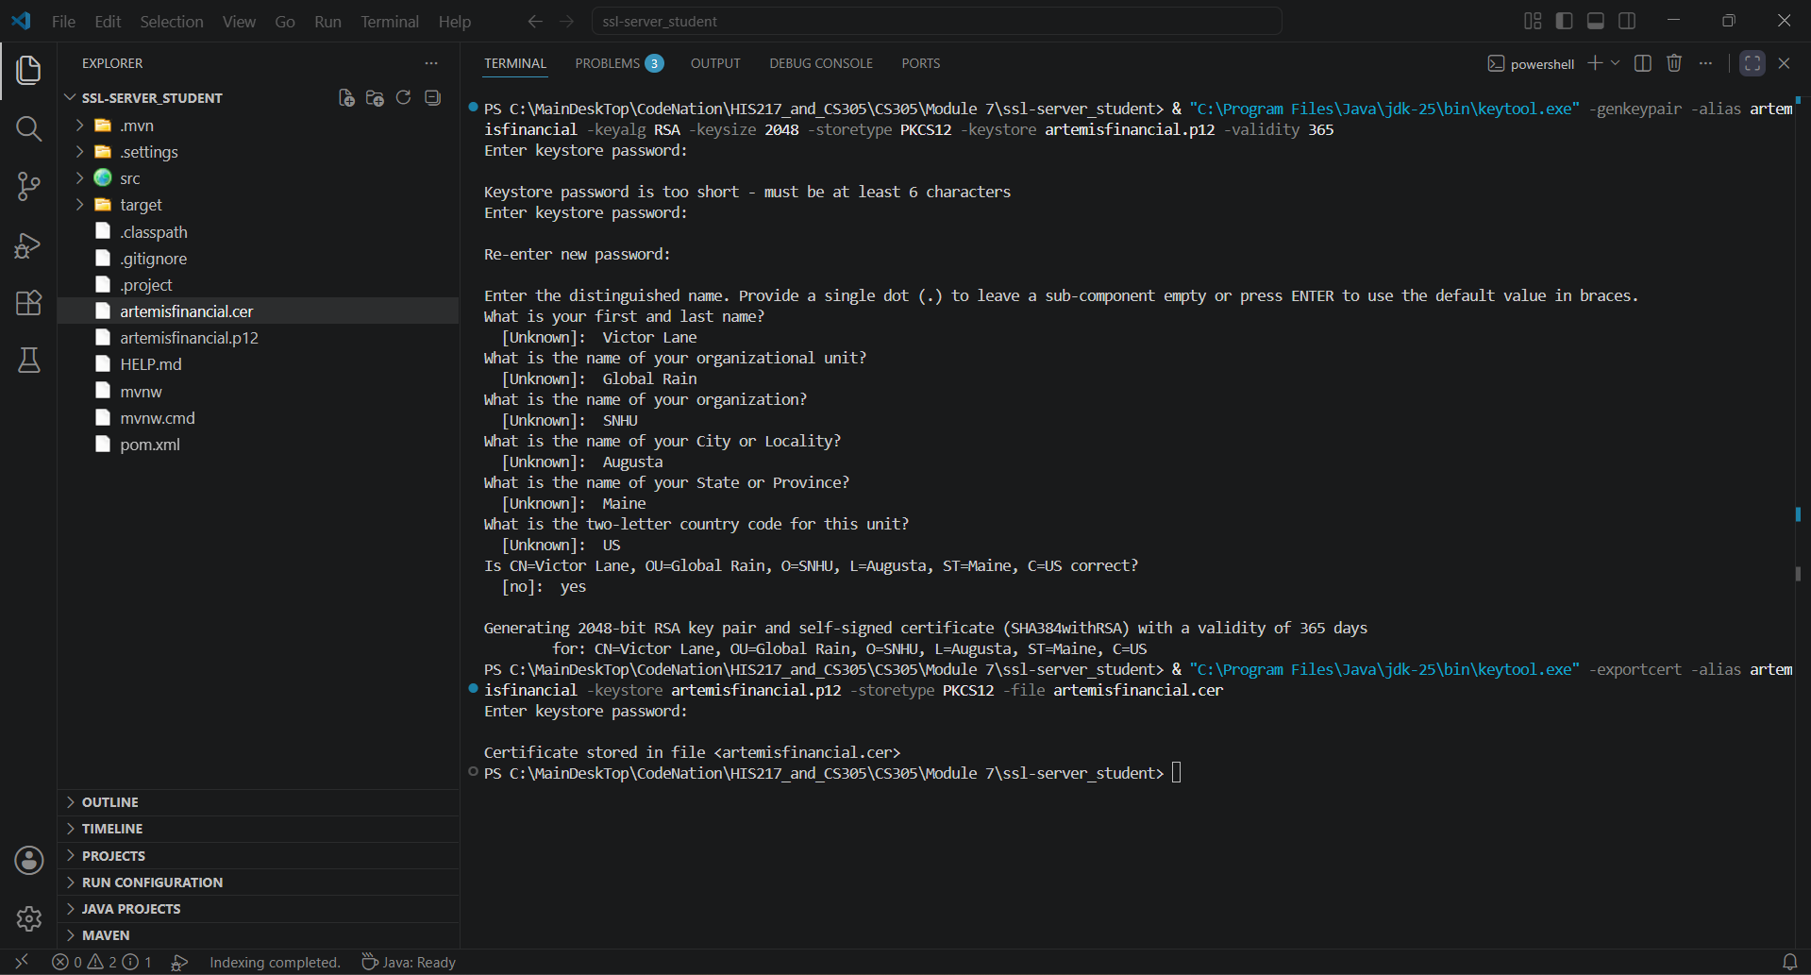

Deploy Cipher
Insert a screenshot below of the checksum verification.

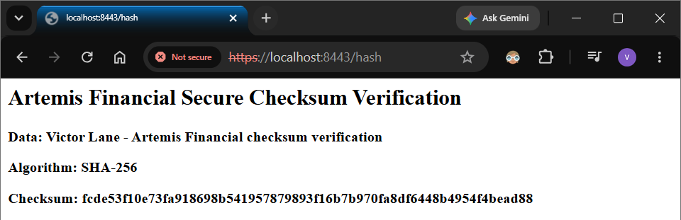

Secure Communications
Insert a screenshot below of the web browser that shows a secure webpage.

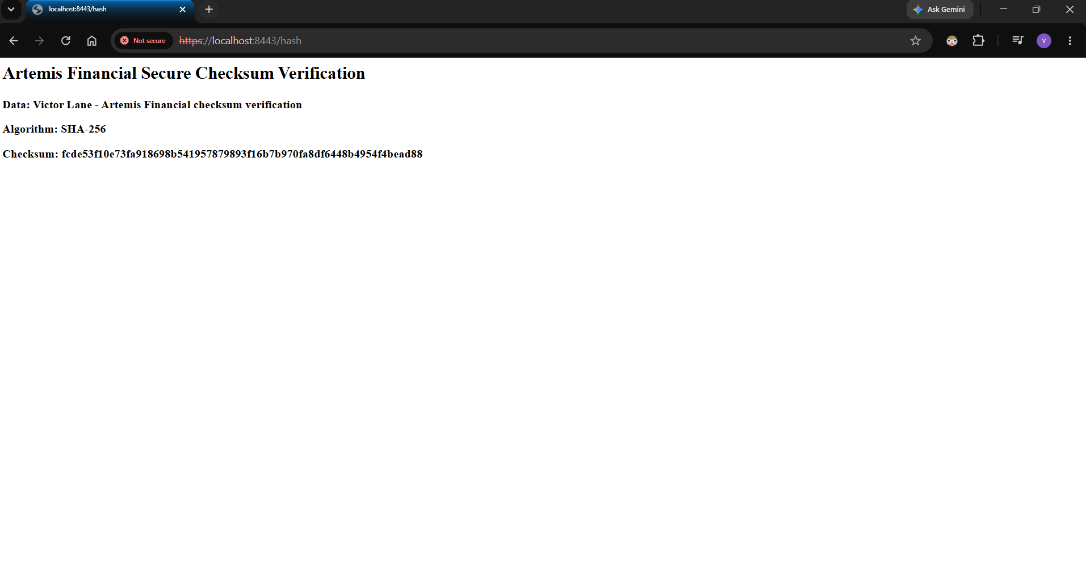

Secondary Testing
Insert screenshots below of the refactored code executed without errors and the dependency-check report.

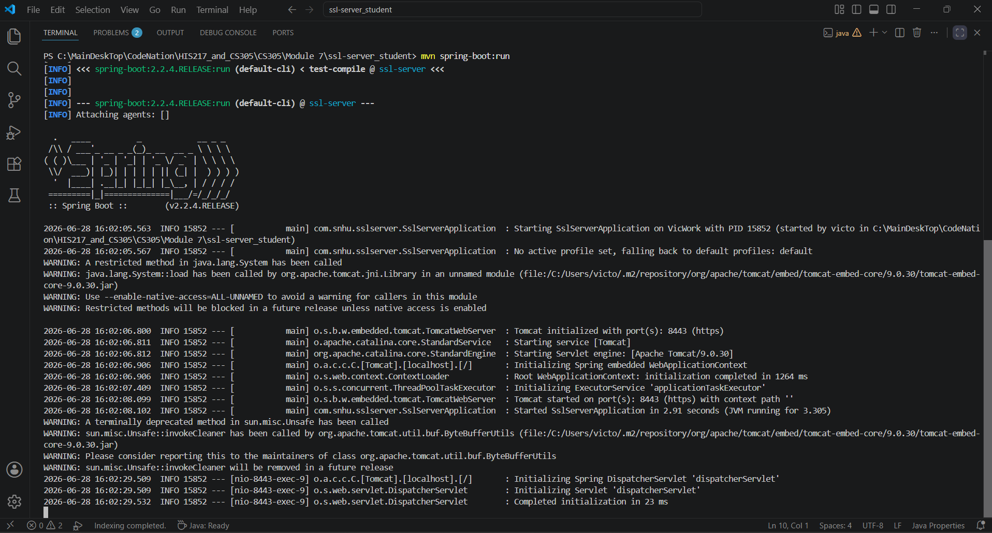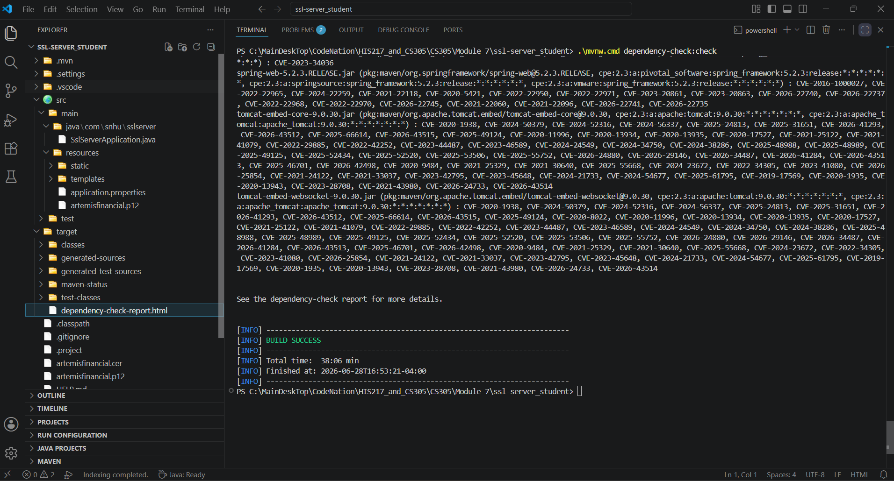
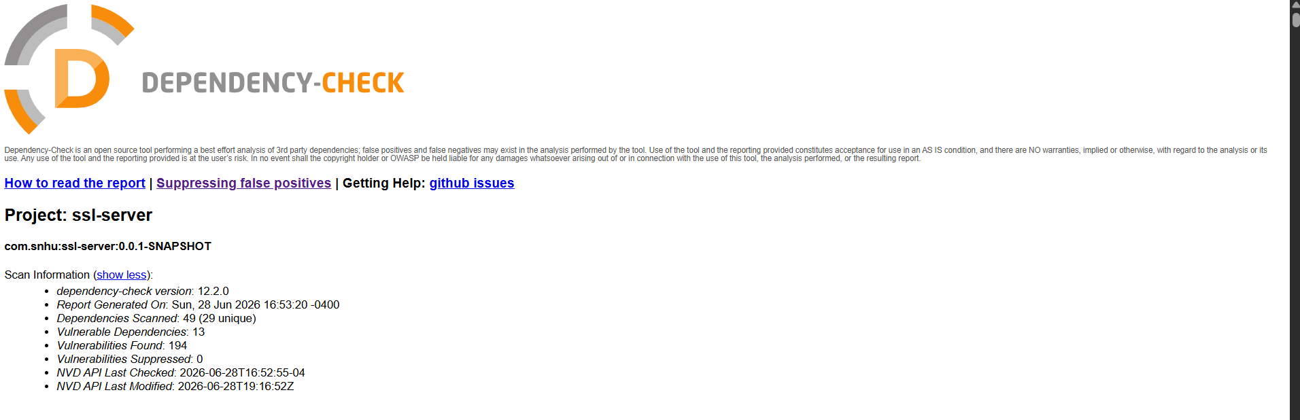
For secondary testing, I ran the OWASP dependency-check tool after refactoring the Artemis Financial application. The test showed that the application executed without errors and that the dependency-check report was successfully created. The report identified vulnerabilities in the project’s existing third-party dependencies, which means the project still has library risks that would need to be reviewed and updated before being used in a real production environment. However, the scan did not show that my added SHA-256 checksum code or HTTPS configuration created new custom-code security problems. This testing helped confirm that the refactored application still ran correctly after the security changes and gave me a clearer view of what dependency issues would need to be fixed next.

Functional Testing
Insert a screenshot below of the refactored code executed without errors.

For functional testing, I manually reviewed my refactored Artemis Financial application to make sure it ran correctly and did not have syntax, logic, or security issues in the code I added. I checked the Java code, application properties file, and Maven setup, then ran the application to confirm it started without errors. I also tested the /hash endpoint in the browser to make sure it displayed my data string, the SHA-256 algorithm, and the generated checksum correctly. For security, I confirmed the application was using HTTPS on port 8443 with the certificate I created. The dependency-check report did show vulnerabilities in existing third-party dependencies, but my refactored checksum and HTTPS code worked correctly and did not appear to add new custom-code security problems.

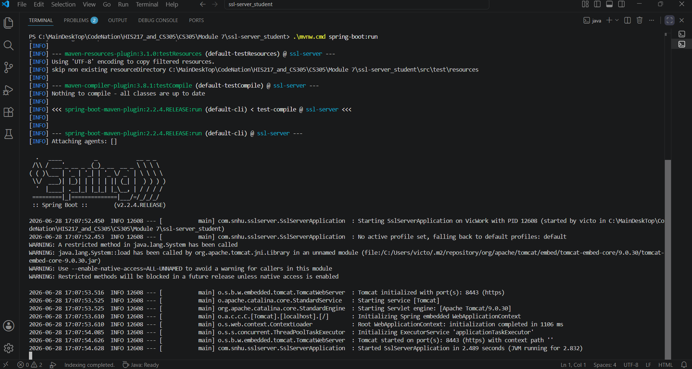
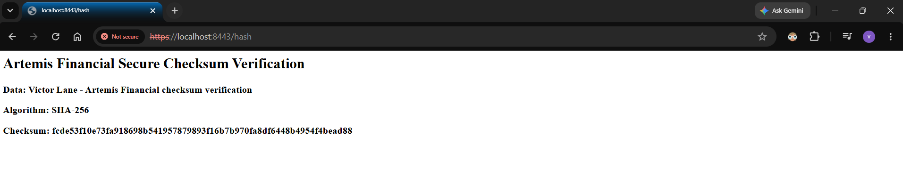

Summary

I refactored the Artemis Financial application by adding a SHA-256 checksum verification feature and converting the application from HTTP to HTTPS. The checksum gives the application a way to verify that data has not been changed or corrupted, while HTTPS adds secure communication between the client and server. Looking at the vulnerability assessment process flow diagram, the main areas I addressed were cryptography, client/server security, APIs, code quality, plug-ins, and code review. I addressed cryptography by using SHA-256 for the checksum and by creating a certificate for secure communication. I addressed client/server security by updating the application properties so the application runs through HTTPS on port 8443. I also reviewed the /hash endpoint to make sure it displayed the expected data, algorithm, and checksum without errors.
My process for adding layers of security started with reviewing the original application and deciding what security features needed to be added. I then generated the certificate, updated the application properties file, added the SHA-256 hashing code, and tested the application in the browser. After the application ran correctly, I used dependency-check as a secondary static testing tool to review the project dependencies. The proof that my refactored code worked correctly is shown through the screenshots where the application starts without errors, the HTTPS /hash endpoint loads in the browser, and the checksum verification displays my data string, SHA-256 algorithm, and generated checksum. The dependency-check report also completed successfully, which shows the project was scanned after the refactoring. While the report showed vulnerabilities in existing third-party dependencies, there were no new issues shown from the checksum code or HTTPS configuration that I added. I also manually reviewed the code for syntax, logic, and security issues. Overall, the refactoring added multiple layers of protection by combining checksum verification, HTTPS communication, static testing, and manual code review.

Industry Standard Best Practices

The main secure coding practices I applied were using a stronger hashing algorithm, enabling HTTPS, testing the application, and reviewing the code for security issues. For the checksum verification, I used SHA-256 instead of older hashing algorithms like MD5 or SHA-1 because SHA-256 provides stronger protection for data integrity. I also updated the application to use HTTPS on port 8443 with a certificate, which helps protect communication between the client and server. These changes support secure communication and help reduce the chance of data being changed, intercepted, or exposed during transfer.
The existing application structure was maintained by making focused security changes instead of changing parts of the program that did not need to be changed. I kept the original application structure in place and added security layers around it, including checksum verification, secure communication, static dependency testing, and manual code review. The dependency-check report helped identify vulnerabilities in third-party dependencies, which is important because secure coding is not only about the code I write, but also about the libraries the application depends on. In a real production environment, the next best practice would be to update vulnerable dependencies, replace the self-signed certificate with a trusted certificate authority certificate, and store sensitive configuration values securely instead of exposing them in plain text.
For Artemis Financial, secure coding matters because client trust depends on keeping financial data protected. The company handles sensitive client financial information, so weak security could lead to exposed data, financial loss, legal issues, and damage to the company’s reputation. Using secure algorithms, HTTPS communication, dependency scanning, and code review helps reduce those risks. These practices also support the company’s overall well-being by making the application more reliable, safer for clients, and better prepared for future security needs.

